2) Write a C program to accept three numbers from the user. Find the greater two among the three and

pass them as parameters to the user defined functions given below.

a) sumaver ( … ) which finds the sum and average of the two numbers. Print the sum and return the

Average.

**#include<stdio.h>**

**#include<string.h>**

**#include<math.h>**

**float sumaver (int, int);**

**void printeven (int, int);**

**int**

**main ()**

**{**

**int a, b, c, large, seclarge;**

**printf ("Enter three numbers\n");**

**scanf ("%d %d %d", &a, &b, &c);**

**large = ((a > b) ? ((a > c) ? a : c) : ((b > c) ? b : c));**

**if ((a > b || a > c) && (a < large))**

**{**

**seclarge = a;**

**}**

**else if (((b > a) || b > c) && (b < large))**

**{**

**seclarge = b;**

**}**

**else**

**{**

**seclarge = c;**

**}**

**float avg = sumaver (large, seclarge);**

**printf ("Average of first two number is %f\n", avg);**

**printeven (large, seclarge);**

**}**

**float**

**sumaver (int a, int b)**

**{**

**int sum = a + b;**

**printf ("Sum of two numbers is %d\n", sum);**

**float avg = sum / 2;**

**return avg;**

**}**

**Output:**

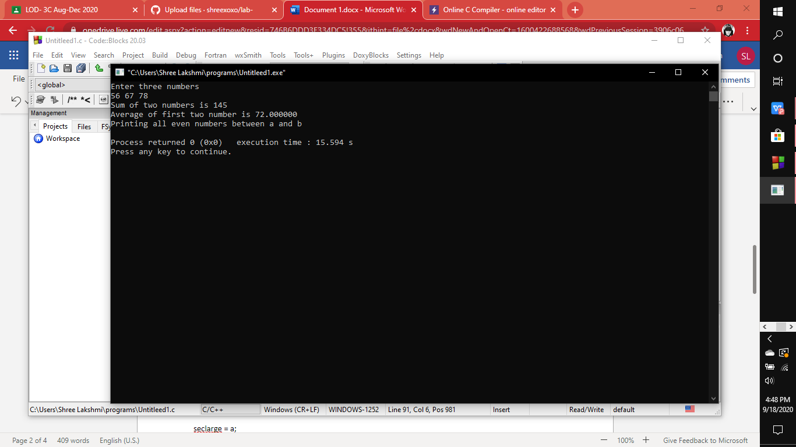

b) **printeven ( … )** which prints all the even numbers between the given two numbers #include<stdio.h>

#include<string.h>

#include<math.h>

int printeven(int,int);

int main()

{

int a,b,c,large,seclarge;

printf("enter 3 numbers\n");

scanf("%d%d%d",&a,&b,&c);

large=((a>b)?((a>c)?a:c):((b>c)?b:c));

if((a>b||a>c)&&(a<large))

{

seclarge=a;

}

else if(((b>a)||b>c)&&(b<large))

{

seclarge=b;

}

else

{

seclarge=c;

}

int x=printeven(large,seclarge);

}

int printeven(int a,int b)

{

int x=a;

int y=b;

printf("printing all even numbers between a and b\n");

for(int i=y+1;i<x;i++)

{

if((i%2)==0)

{

printf("even numbers %d\n",i);

}

}

}

Output:

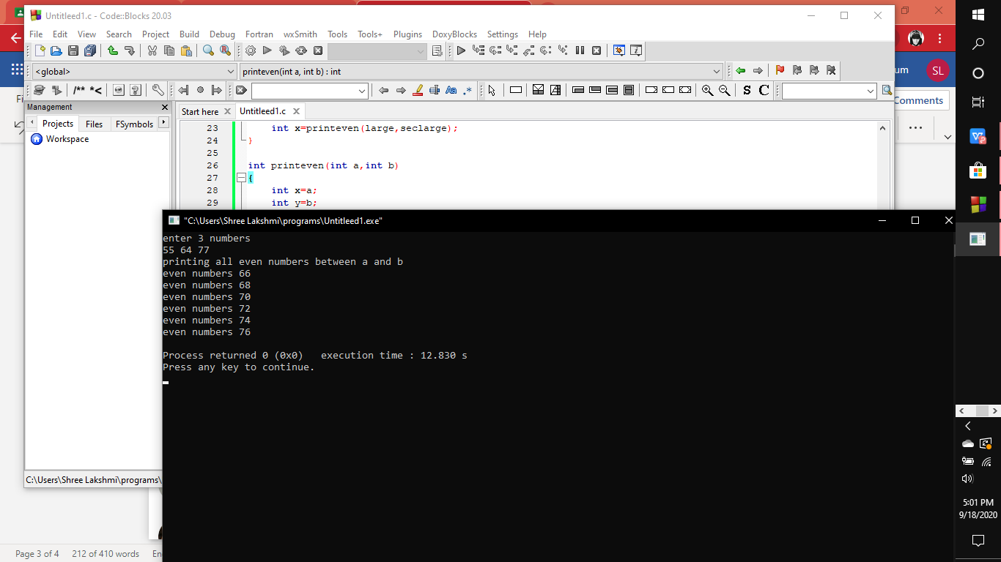

Program 1:

#include<stdio.h>

void main()

{

int no1,no2,result,choice;

printf("Enter two numbers:");

scanf("%d %d",&no1,&no2);

do{

printf("1.Add\t2.Subtract\t3.Multiply\t4.Divide\t5.Modulus\t");

printf("6.less than\t7.NotEqual\t8.Greater than \t9.Greater than or equal to\t");

printf("10.Less than or equal to\t11.Exit \tEnter your choice: ");

scanf("%d",&choice);

switch(choice)

{

case 1: result=no1+no2;

printf("Sum= %d\n",result);

break;

case 2: result=no1-no2;

printf("Difference= %d\n",result);

break;

case 3: result=no1*no2;

printf("Product= %d\n",result);

break;

case 4: result=no1/no2;

printf("Quotient= %d\n",result);

break;

case 5:result=no1%no2;

printf("Remainder= %d\n",result);

break;

case 6:if(no1<no2)

printf("Number1 is less than Number2\n");

else

printf("false\n");

break;

case 7:if(no2!=no1)

printf("Number1 is Not Equal to number2\n");

else

printf("false\n");break;

case 8:if(no1>no2)

printf("Number1 is greater than Number2 \n");

else

printf("false\n");break;

case 9:if(no1>=no2)

printf("Number1 is gerater than or equal to Number2\n");

else

printf("false\n");break;

case 10:if(no1<=no2)

printf("Number1 is less than or equal to Number2\n");

else

printf("false\n");break;

case 11:break;

default:printf("Invalid choice");

}

if(choice == 11)

printf("\n Your Exiting the Programe\n");

}while(choice!=11);

}

